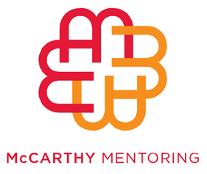
McCarthy Mentoring Not For Profit Executive Scholarship
APPLICATION FORM
Applications close 5pm, Thursday 12 February 2015

Name
Address
Postcode
Telephone (w) (M)
Email:

      - Current employer

      - Position title

      - Title of the person you report to

      - Key responsibilities on the executive leadership team

      - What are the three key issues you are facing in your current role?

      - How do you imagine a mentor could support you?

      - What are your ambitions for your organisation?

      - Have you received a scholarship from any other organisation in the past three years? If so, please provide details.

Please provide details of two referees. At least one referee must be your CEO or Board Director.
- Name
- Position
- Telephone
- Email

- Name
- Position
- Telephone
- Email

Please send this application form with a copy of your CV through to enquiries@mccarthymentoring.com . For further queries please phone 02 8958 5365
NB: All applicants confirm that the information in this reference is true and correct. Applicants also accept that McCarthy Mentoring has the right to reject an application or retract the award of the scholarship on the basis of false or misleading information forming any part of the application. All applicants will receive an email confirming the receipt of the application. The scholarship recipient will be notified by March 2015.

